

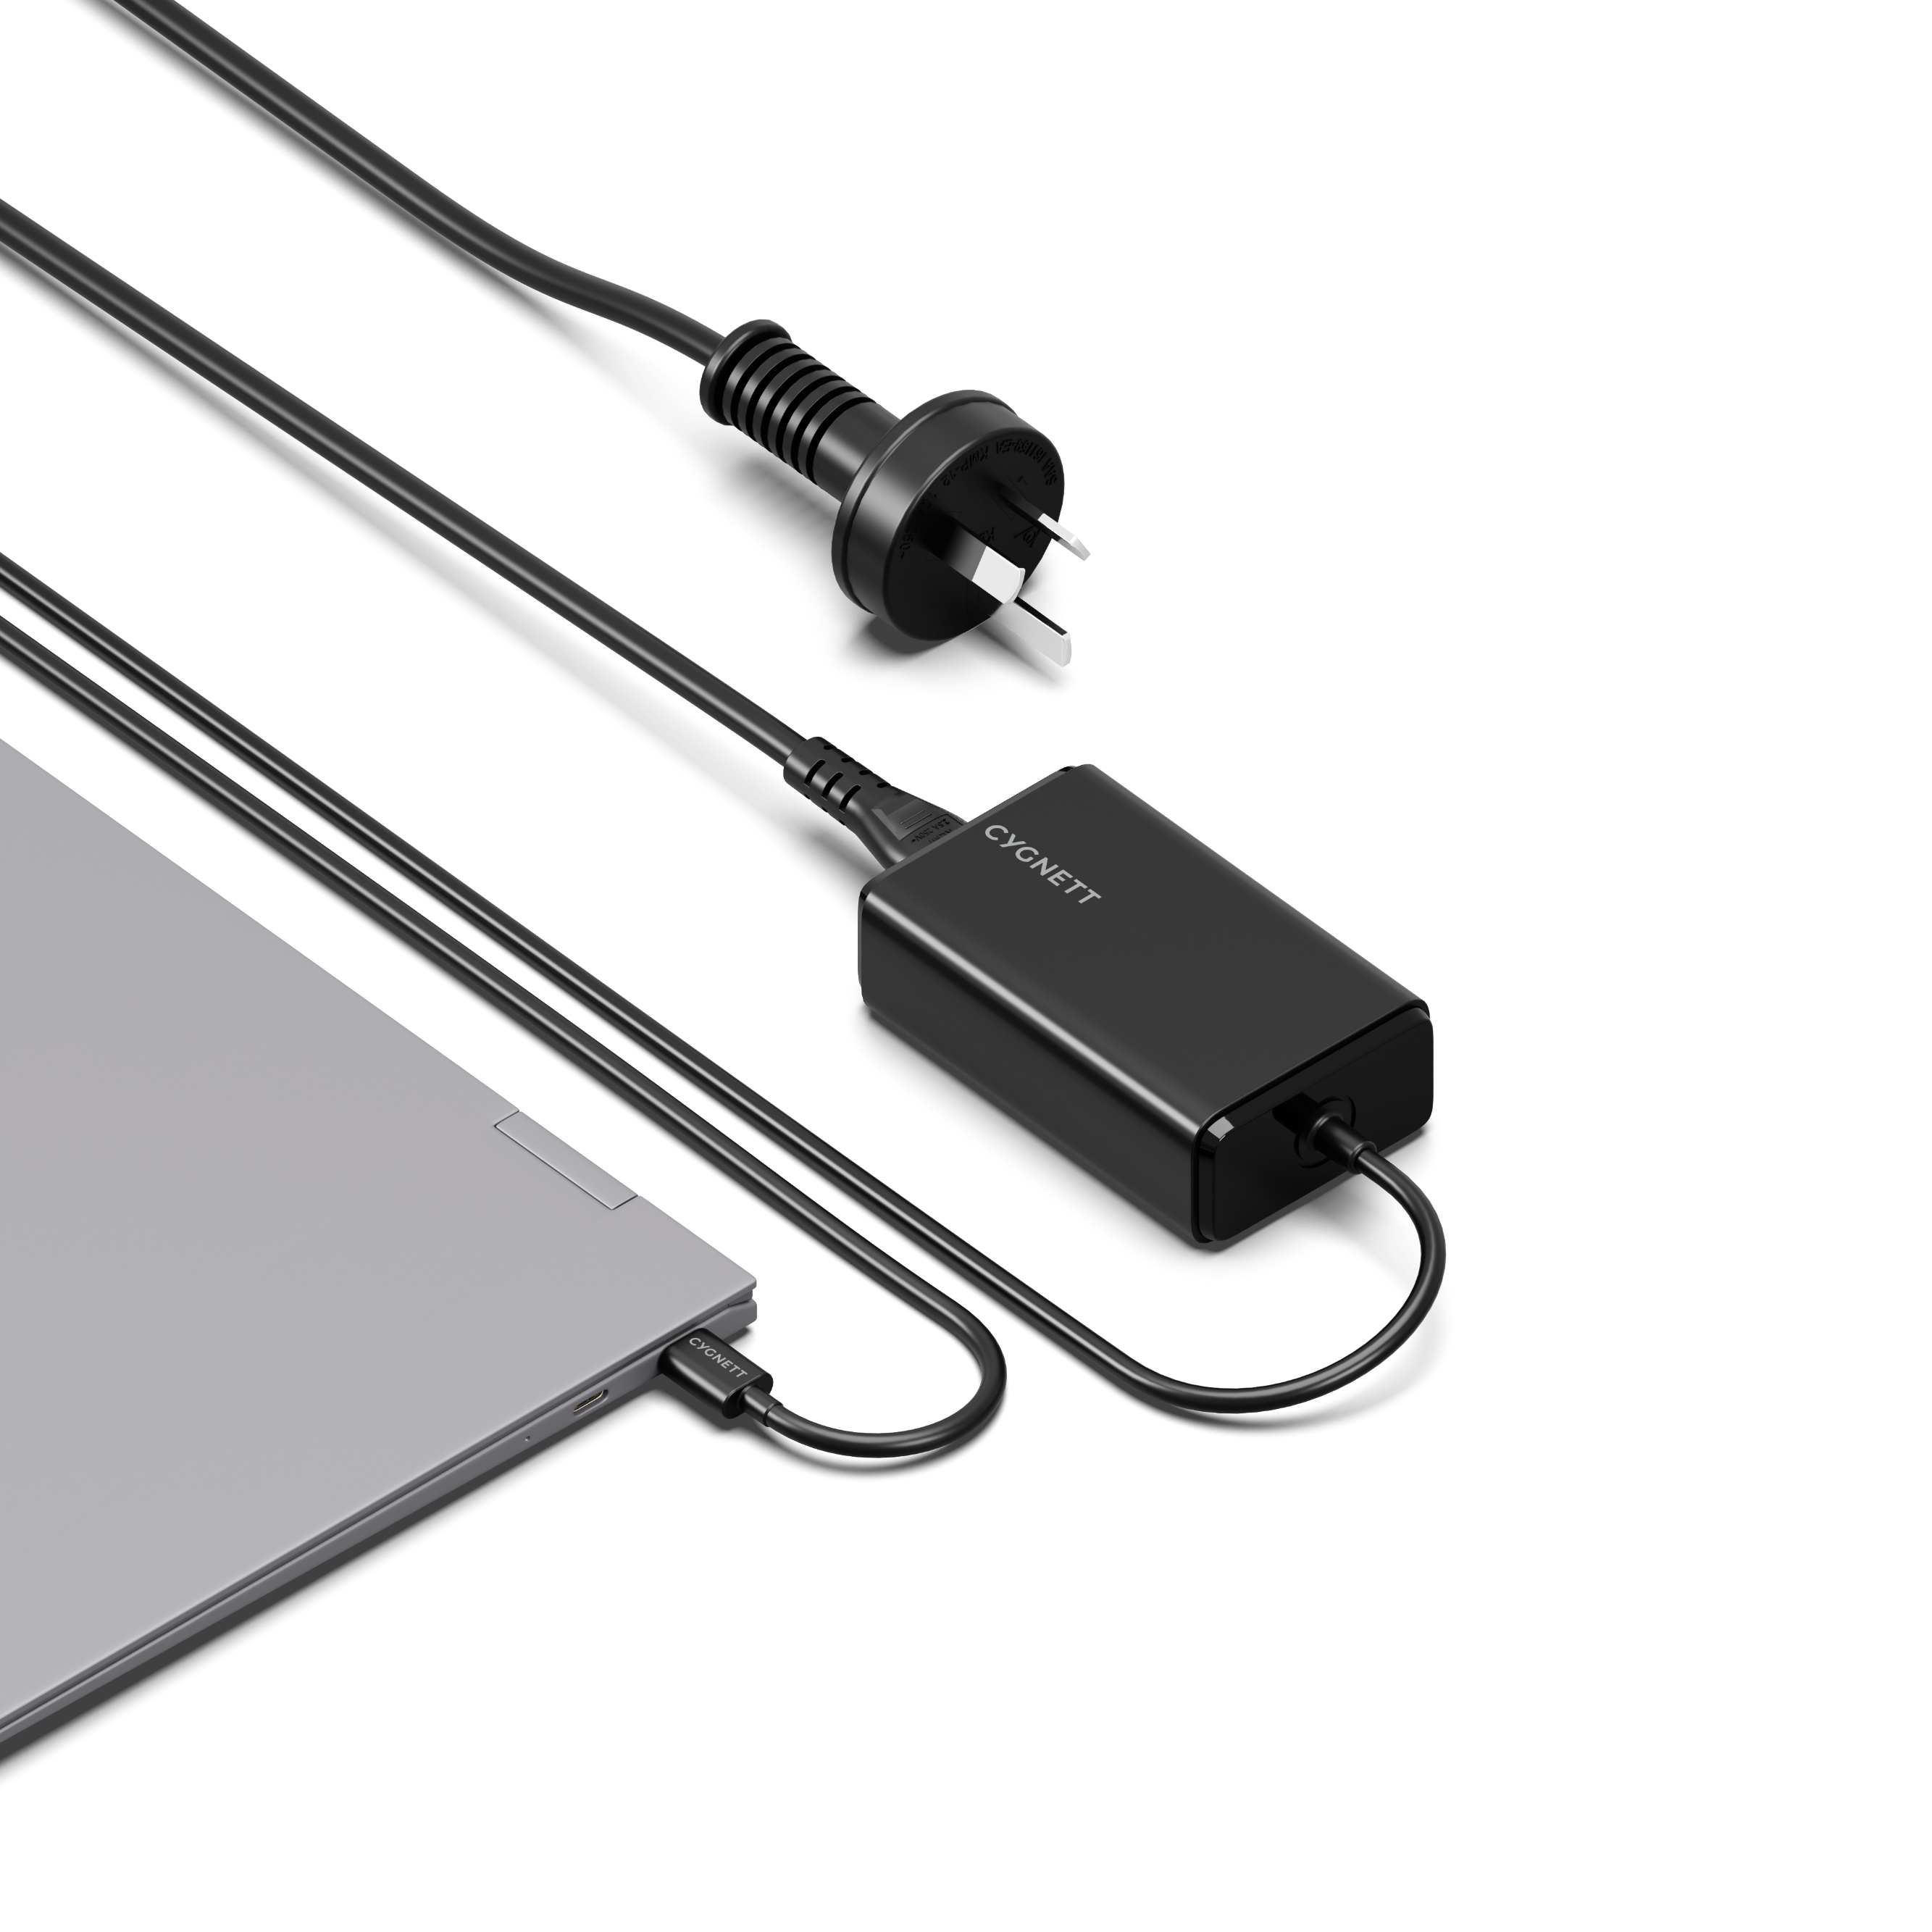

SKU: CY5071PDWCH

POWERMAXX
65W USB-C GaN LAPTOP CHARGER

Whether you're charging a laptop, tablet, phone, or gaming device, this charger delivers 65W USB-C power to your USB-C devices, getting them back to full power and running smoothly. Charge with confidence knowing this charger has robust protection against overheating and overcharging.

PRODUCT HIGHLIGHTS
PRODUCT HIGHLIGHTS

- Charges laptops, phones & tablets
- 65W USB-C Power Delivery
- GaN technology
- Integrated 1M USB-C charging cable
- 2-year warranty
Charger faster and smarter with GaN
With advanced GaN technology, you can power-up your laptop faster and more efficiently than traditional chargers. GaN technology lets power flow faster from this charger to your USB-C device, whilst also helping prevent overheating. Less heat = more efficient charging.

65W laptop charging
Stay powered and stay productive with 65W USB-C PD charging power to your laptop. Perfect for professionals, gamers, and anyone on the go—this compact charger is the ultimate companion for your tech.

Fast charging a wide range of USB-C devices
This charger is perfect for fast charging USB-C tablets, drones, phones and other devices that accept USB-C charging. Connect any of these devices and the charger will automatically detect the power needs of the connected device and deliver a safe, fast charge.

Integrated 1M USB-C charging cable
No additional charging cables needed, this charger comes with an integrated 1M USB-C cable that plugs directly into your laptop or other USB-C devices.

SPECIFICATIONS

INPUT:
- AC: 100-240V, 50-60Hz, 1.5A Max

USB-C OUTPUT:
- 5.0V-3.0A (15.0W)
- 9.0V-3.0A (27.0W)
- 12.0V-3.0A (36.0W)
- 15.0V-3.0A (45.0W)
- 20.0V-3.25A (65.0W)

TOTAL OUTPUT: 65.0W Max

